Field Trip Planner

Table of Contents:

Welcome……………………..………………………………………………………....................3
Planning Your Trip……………………………………………………………………………..…5
Field Trip Educational Activities……………………….…………………....................................7
Site Rules and Regulations………………………………………………………………………12 Appendix-The Rules of Town Ball……………………………………………………………….15

Hello Educators!

Welcome to Bentonville Battlefield State Historic Site! We are so glad that you are interested in a trip to our site and hope that this document provides most of the answers to questions you may have. I am Colby Lipscomb, Education Coordinator at Bentonville and I’ll be more than happy to answer any further questions, my contact information is listed below.

Bentonville Battlefield is the site of the battle of Bentonville, one of the last major battles of the Civil War and the largest battle ever fought on North Carolina soil. The site today interprets the history of the battle itself, the tactics and the people involved, the broader story of the Civil War in North Carolina, as well as 19th century farm life. With such broad subject matter, there is no doubt your students can take much away from a planned visit to our site.

Field trips are one of our favorite opportunities as a historic site because we get to work directly with students in their classes and encourage discussion about the Civil War at a place where that history actually happened. There is nothing like seeing the look on a student’s (or teacher’s) face when they first step into the Harper House and see the bloodstains on the floor. There is something so visual and experiential about the learning at a historic site that makes it much more real for learners.

We have several hands-on, staff-led activities we encourage teachers to take advantage of while on site. You can reserve up to two of these activities. Most recently we have added a STEM-based activity titled “Treating the Wounded at the Harper House,” that replaces the traditional tour with an activity that encourages students to think through different perspectives of the battle as well as problem solving with resources and treatment. We also offer students a chance to get outside and be active, playing the 19th century version of baseball, town ball. And, when staffing allows, we can provide a musket demonstration where students will see and hear what common soldiers looked like and how they fired their weapon.

In addition to guided activities we also have extensive walking trails, a driving tour, monument area and Harper family cemetery, that are all optional and self-guided. We have ample picnic space for food and can be very flexible with your schedule and individual needs.

Below is a much more detailed overview of what we have to offer. If you have any questions or want to book a trip, feel free to contact me!

Thank you,

Colby Lipscomb
Education Coordinator, Bentonville Battlefield State Historic Site
colby.lipscomb@ncdcr.gov
(910)-594-0789 ext. 204

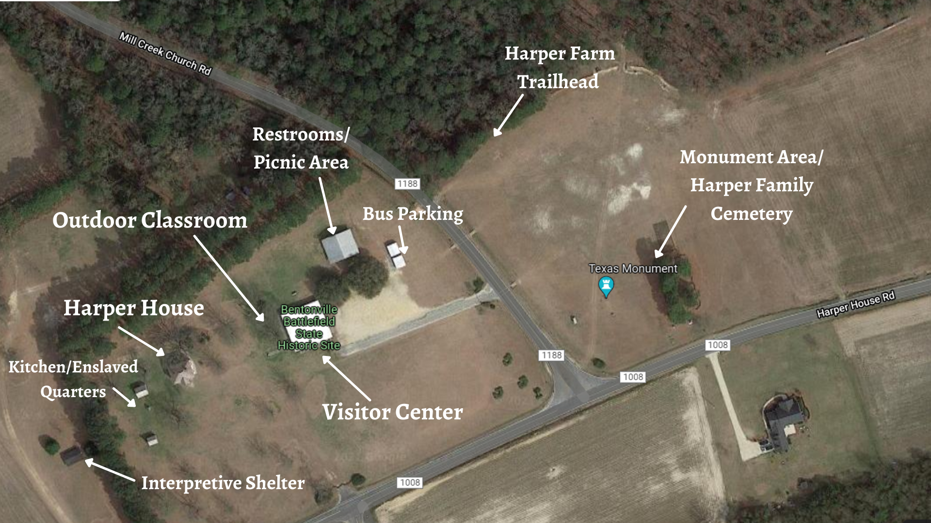
Satellite Map of the Visitor Center area at Bentonville Battlefield State Historic Site

Planning Your Trip:

Group reservations are on a first come first serve basis, therefore please contact the site as soon as possible to schedule your group. Reservations are required two weeks in advance. Bentonville Battlefield State Historic Site will remain open to the general public during group tours. We need to know your grade level, approximate number of students, the number of chaperones (at least 1 for every 10 children is suggested), the date and time of your arrival, and your contact information.
E-mail with a timeframe you have in mind and we’ll get back to you with a few open dates. When you find a date that is open fill out a Google form to reserve your trip and confirm your date.

- Upon arrival, groups should remain in the parking area while you (the teacher or group leader) check-in with the site staff in the Visitor Center. PLEASE keep your students organized during this time, we do not want to begin the field trip in chaos. This would be a great time to make use of the restrooms located in the building with red barn doors, adjacent to the Visitor Center.
- The average tour of Bentonville includes watching the film, one or two staff-led activities, self-guided exploration, and optionally the gift shop. These activities will take a minimum of 1 ½ hours. Lunch under the shelter, the monument area, and the driving tour will add to the time your group spends on site.
- Site staff need to know how long you plan on spending and your chosen activities before you arrive so that we can plan accordingly! Staff will develop itineraries and go over them with you when you check in. Staff are happy to adjust the trip to your needs or are happy to suggest what has worked in the past with other groups.
- Large groups (thirty-five or more, including chaperones) are divided into two or more smaller groups. Please have assigned groups and chaperones prior to arriving at the site, usually we recommend keeping classes together as a group but having smaller groups assigned to chaperones for breakout sessions. Each group will rotate between stations and the time will vary depending on the number of stations.
  - One Group (<35 participants): Students will stay together throughout the trip. Beginning with Orientation Film, then proceed through other formal programming before letting out into self-guided exploration.
  - Two Groups (35-70 participants): Stations will be assigned depending on chosen activities. The groups will rotate between activities and watching the film.
  - Three Groups (70-100 participants): Groups will be assigned to stations, one in the Visitor Center, the other two in assigned activities. Each group will typically spend 25 minutes at one station and then rotate.
  - Four Groups or more (100+ participants): If there are four rotations necessary, they will entail watching the film/viewing exhibits, two activities, and a self-guided activity of your choosing.
  - Bentonville cannot accommodate groups over 150, contact us if that’s the case
- Please wait until the end of your visit for gift shop sales. Gift shop visits are optional. Be sure to let staff know if you plan on visiting the gift shop. Only ten students are allowed in the gift shop at one time and must be supervised by at least one chaperone. Site staff will keep the gift shop closed to students until the end of the visit to help keep their attention on the Visitor Center exhibits. When it is time to visit the gift shop, we ask that you line your students up at the front door or hold them at the picnic area, with a chaperone keeping count.
  - Teachers should note that toy 19th century muskets, pistols, and swords are available for purchase in the gift shop; please let the staff know ahead of time if your students are not allowed to purchase these items.
While on Site:
Please encourage your students to wear comfortable shoes and clothing. You will be doing some walking; some activities require more physical activity than others so come prepared. Although the Visitor Center and the Harper House are both heated and air-conditioned, the outside area is very warm in the late spring and summer and very cool during the late fall and winter.
Bentonville Battlefield State Historic Site is open every week of the year, with March, April, and May being our most popular group visitation months. You are welcome to reserve a visit during those months, but a more relaxed and enjoyable visit might occur during the fall, when we are not as busy.
Please remind your students that most of the items in the Visitor Center and the Harper House are from the Civil War era, meaning they are at least 150 years old. PLEASE do not bring food, drink, or gum inside the Visitor Center, Harper House, or outbuildings, and do not touch any of the artifacts.
Please familiarize yourself with the site rules. A copy of those rules is attached to this document. Remember that the behavior and discipline of your class is the responsibility of you and your chaperones. Site employees, or appointed volunteers, reserve the right to cancel your visit if the students’ conduct is detrimental to the site or to the enjoyment of other visitors.

Example Field Trip Itinerary for group with two classes:

10:00: Arrival: Split into 2 groups, visit restrooms.

10:15: Group 1 watches the film and visits exhibits, Group 2 watches Musket Demonstration

10:45: Group 1 watches Musket Demonstration, Group 2 does Treating the Wounded Activity

11:15: Group 1 does Treating the Wounded Activity, Group 2 watches film and visits exhibits

11:45: Groups eat lunch and explore the gift shop in smaller groups with chaperones

12:15: Self-guided exploration at monument area and walking trail

12:45: Restrooms and gathering

1:00: Depart

Educational
Activities
On-Site

Educational Programming:

All educational programs are available to all grade levels, but some may be better suited for a particular age group, feel free to reach out and we can discuss what options might be best for you. Some components are staff guided while others are teacher-led. The option for self-guided walking tours and driving tours is always available, depending on your schedule.

The battlefield is vast and offers opportunities to tell many different types of stories and focus on different aspects. All Field Trips view the Orientation Film because it gives students the clearest idea of the context of the battle. Field Trips also include between 1 and 2 staff-led activities. Most popularly these include the Harper House and a Soldier’s Life talk, but we have other options if they may work better for you and your plans. We also have plenty of self-guided options for you to pursue to add to the educational opportunities onsite. You should allocate at least 2 hours for your visit. Please allow time for bathroom breaks, gift shop sales, and transitions from station to station in your planning. Every effort will be made to satisfy your requests; however, staff reserves the right to alter planned programming due to inclement weather or unanticipated staff shortages. If you have questions about scheduling your group tour, such as the recommended amount of time to spend on each activity, please contact us.

Main Programs (All Field Trips):

- Visitor Center – (Approx. 25 minutes)
- The first stop in the Visitor Center, our fifteen-minute orientation film, gives a brief synopsis of the Civil War and explains how the Battle at Bentonville came about.
- Optionally, after the film, students can walk through our interpretive exhibits, see artifacts from the battle, and watch a six-minute fiber optic map program, which outlines the troop movements during the battle.

Optional Guided Activities (Choose Two):

- Treating the Wounded at the Harper House – (Approx. 25 minutes) In this immersive program, students will follow the experiences of an individual at the Harper House field hospital during the battle. Assigned distinct identities, participants will take on their new role and see the Harper House hospital through the eyes of a surgeon, hospital steward, or wounded soldier as they tour through the house. In a multi-step program, participants will work in teams to develop their own system of organizing wounded soldiers (triage), decide how best to treat wounds of varying severity, and contemplate how to provide for recovering soldiers, while learning how their historical counterparts handled the same situation. Through inquiry, students will solve the same problems their counterparts did in 1865. Following the program, participants will be encouraged to discuss how their solutions compared to those of their counterparts and compare and contrast how the same situations would be handled today. By following real historical soldiers and solving real historical problems, participants will use STEM-based learning to identify with and immerse themselves in the medical history of the Civil War at the Harper House and Bentonville Battlefield State Historic Site.
  - Students will then visit the outbuildings of the house, the kitchen and the enslaved people’s quarters. (In some cases, staff may schedule the outbuildings as a separate station)
- Small Arms Weapon Demonstration (Musket Demo)– (Approx. 25 minutes) Students will learn about the weapons commonly used during the Civil War, as well as the uniform and equipment carried by a soldier. An interpreter in Civil War uniform demonstrates the loading and firing of reproduction Civil War rifle musket and discusses the science behind it. Staffing may not always be available for this demonstration, so be sure to get confirmation from the Education Coordinator.
- Soldier’s Life Discussion – (Approx. 25 minutes) Students will learn from an interpreter in Civil War uniform about the life of a soldier on the march and in battle. Discussing camp life, foodways, drills, and the lives of individual soldiers, this program gives a great insight into the soldier during the Civil War and sets up well with the Treating the Wounded program that follows soldiers after wounding.
- Medal of Honor – (Approx. 25 minutes) Students will learn about what it means to be brave and why the US military honors bravery. Interpreters will discuss what the Medal of Honor is and talk about the four individuals who received the Medal of Honor due to their actions during the battle. Then students are encouraged to create their own medal using a worksheet.
- Nature of Bentonville – (Approx. 25 minutes) Students get to create their own art through leaf rubbing and learn about the natural side of Bentonville. Interpreters will discuss the nature of Bentonville and the role of trees including the state tree of NC, the pine tree, and others. Discussing the historical role of nature during the battle as well as its role today, this activity includes the take home and pairs well with a self-guided walk down the nature and history trail.
- Town Ball - (Approx. 25 minutes) Town ball was the nineteenth-century equivalent of baseball. The rules are slightly different, but a staff member will facilitate the game and explain all the rules. This activity is extremely popular with our middle school groups. (See Appendix for the rules of town ball.)

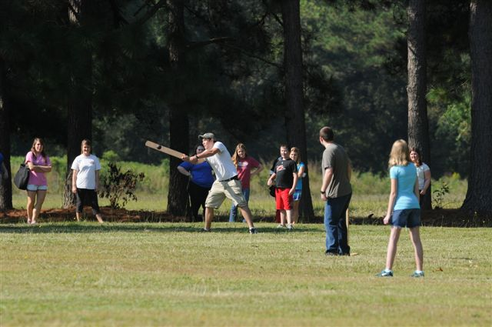
Students play Townball, a 19th century form of Baseball

Self-Guided Activities (Time Permitting)
The following activities are available as “self-guided” activities during your trip to the battlefield. These activities do not require staff facilitators, and your class may participate in them at leisure and at your own pace if your group has extra time to spend at the Battlefield. Please ensure that if you choose to participate in one of these activities that each group of students has at least one chaperone to ensure that the site rules are enforced, for this we recommend smaller groups of 5-10 students per group to ensure better supervision.

- Harper Family Cemetery and Monument Area – Here students can visit the Harper Family cemetery, and the graves of Confederate soldiers cared for by the Harper Family after the Battle of Bentonville. Monuments here honor both Union and Confederate Soldiers. This is a great opportunity for students to adventure in a less structured environment. (Approximately 10-15 minutes)

- Harper Farm Walking Trail and Trenches – This teacher (or chaperone)-guided ¼ mile walking trail takes students to a trench line used by reserve troops during the battle. On this trail, students will see reconstructed field fortifications and a replica cannon as well as interpretive panels that explain more information. An optional trail extension has been added which brings the trail total to nearly one mile. This area is located near the woods line across Mill Creek Church Road from the Visitor Center. (Approximately 20-40 minutes)

- Bentonville Battlefield Junior Historian – Become a Junior Historian by completing the small activity booklet. Usually costing $2 and including a badge, the booklet is free for school groups (does not include badge). Including a word search, drawing activity, letter writing activity, and maze, this is fun for all audiences and an additional activity for self-guided exploration.

- Battlefield Driving Tour – Upon request, groups may receive a map that will guide them to four tour stops on the battlefield. At each stop there are interpretive panels describing the action that took place at that location. There is also an audio component to the tour, in which you can dial a certain number from your cell phone and learn more about the battle at that particular site. Three of the four pull-offs are capable of handling large buses. The driving tour is about a 10 mile loop, so you can decide how quickly or slowly you would like to move through the tour. (Approximately 45 – 60 minutes)

Offsite Activities:

- Virtual Field Trip – Our Virtual Field Trip offers an interactive website with videos, text, photos, activities, trivia, and more for students from 3rd – 8th grade to virtual visit Bentonville Battlefield. With three sections including The Setting (discussing nature and the community), The Battle (discussing the battle and the people involved), and The Aftermath (discussing the treating of wounded and the toll a battle takes on people), the VFT can be done at various times and has different activities that can be assigned for different grade levels. A For Educators section details the appropriate standards for each activity! Contact the site for a link to our FREE Virtual Field Trip!
- School Visit – Our interpretive staff can provide school visits that include discussions and activities based on those done onsite or a School of the Soldier talk that focuses mostly on life of the Civil War soldier. Contact the Education Coordinator to reserve a visit.
- Traveling Trunk - Bentonville Battlefield has a trunk containing objects that would have been regularly used by a soldier during the Civil War, such as a canteen and various articles of clothing. Teachers have the option of requesting the trunk to be sent to their school prior to their visit or in place of a visit. The trunk comes with lesson plans or can be adapted to fit a teacher’s own lesson plan.

Educational Tracks

To help expedite the process and make it easier, we have identified a few educational tracks that you can follow that identify specific programs that work well together and give the staff an idea of how to focus their interpretation to most benefit your class. All tracks include watching the Orientation Film.

- Blood and Germs Track – This track takes a STEM approach to the history of the battle of Bentonville. Students listen to a Soldier’s Life Talk about life in camp and during battle and discover just how disgusting and dangerous it was. Then they get to act as a surgeon themselves in Treating the Wounded at the Harper House Activity. End the field trip with a journey to the Monument Area and Cemetery to learn about the cost of war and see the graves of some of those treated at the Harper House.
- Soldier’s Life Track – Students will follow the experience of a soldier at Bentonville through their trip with an ID card that identifies a specific soldier who fought here and was treated at the Harper House. First listening to a musket demonstration and discussion, they can learn about what their soldier experienced during the heat of battle and how they were likely injured. Then walk through the Harper House and discover how they would have been treated and finally, if they lived or died. Finish the trip with a Junior Historian booklet to complete activities about the life of a Civil War soldier.
- Science and Nature Track – Learn about the natural side of the Civil War and of Bentonville through this track. Students can learn about leaves and the lives of trees through our Nature of Bentonville activity and have fun with a leaf rubbing activity. Then listen to a Soldier’s Life Talk that focuses on camp life and how soldiers lived in such harsh environments. Finish the trip with a walk down the Nature and History Trail and see trenches built during the battle.
- Life in the Civil War Track – Learn about soldier’s and civilian’s lives during the Civil War through a Musket Demonstration that focuses on the duties of soldiers and how soldiers lived their day to day lives. Then play Townball, 19th century baseball, to see what kinds of games people during the Civil War played. Finally, check out the outbuildings to learn more about farmers and enslaved people’s lives during the Civil War. Finish with a visit to the Harper Family cemetery to see a family graveyard and learn about the Harpers lives.

Historic Site Rules and Regulations

North Carolina Administrative Code for the Department of Cultural Resources-Archives and History- N.C. Historic Sites

07 NCAC 04N .0102 ACTIVITIES PROHIBITED ON STATE HISTORIC SITE PROPERTY

- On state historic sites property, a person may not, unless specifically authorized to do so by written permit or work order from the Department of Cultural Resources:

  - Remove, deface, or destroy any natural feature, plant animal, mineral, or human-made object;
  - Dig, plow, or otherwise disturb existing ground conditions;
  - Drive or park a vehicle in places other than a designated public roadway or parking area;
  - Allow an animal under his care to be unrestrained or to enter a site building or historic feature, unless that animal is a guide dog for a legally blind person;
  - Ride or dive an animal in places other than a designated public roadway;
  - Enter, leave or remain on site property at any time other than normal hours of public visitation. The schedule for public visitation is posted at each site; variations from this schedule are announced via print and broadcast media;
  - Advertise, promote, offer for sale, or otherwise solicit for a product, service, candidate, charity, or public or private cause;
  - Cross any railing, fence, barricade, or marked safety perimeter, or otherwise attempt to defeat the purpose of any security or safety device;
  - Carry on his person any firearm, projectile-firing device, explosive or other weapon;
  - Create a fire hazard by having any open flame or burning material inside any building unless the person is in a designated smoking area, or by kindling fires in any place other than designated cooking grills;
  - Disrupt the public enjoyment or normal operation of a state historic site by any form of commercial or for-profit activity;
  - Bathe, wade, or swim in any waters in any state historic site except at such places as the Department may designate as swimming areas. In this Rule “swimming area” means any beach or water area designated by the Department as a place for swimming, wading, or bathing.
- On state historic sites property, a person may not under any circumstances:

  - Create any pollution or environmental hazard by improper disposal of trash, garbage,
waste-water, or other detrimental substance;
  - Hunt, fish, or otherwise disturb, injure, or destroy wildlife;
  - Use or carry a metal detector, probe, or any similar instrument used for remotely sensing the presence of objects or features at or below ground level;
  - Create a fire hazard by improperly discarding burning or smoldering material.

History Note: Authority G.S. 121-4(8); 121-4(9); 143B-62(2)d;
Eff. February 1, 1985;
Amended Eff. June 1, 1989.

07 NCAC 04N .0103 AUTHORITY OF SITE PERSONNEL

When on state historic site property, a person may not disobey an order of a site manager or other site employee when that order is related to the preservation of historic material, the protection of historic sites property, the safety or well-being of the visiting public, or the equality of access of all citizens to the resources of the site.

History Note: Authority G.S. 121-4(8); 121-4(9); 143B-62(2) d;
Eff. February 1, 1985.

07 NCAC 04N .0104 PERMIT REQUIRED FOR SPECIAL SITE ACTIVITIES AND EVENTS

A person shall at least 15 days before the scheduled beginning of the activity or event, apply in advance to the manager of the state historic site for a permit to use that site’s property or facilities for any activity or event which will:

- Interfere with the visiting public’s normal access to use or enjoyment of the site.
- Require site personnel to provide special preparation, assistance, or service not otherwise furnished to individual or group visitors under the site’s general public policy and program;
- Result in any violation of other rules in this Sub-chapter; or
- Represent a use of the site for purposes other than those associated with historic preservation or public history education.

History Note: Authority G.S. 121-4(8); 121-4(9); 143B-62(2) d;
Eff. February 1, 1985;
Amended Eff. June 1, 1989.

07 NCAC 04N .0105 PERMIT APPLICATION REQUIREMENTS

A person shall, in applying for a permit, provide the site manager with a written description of the proposed activity, the description to include:

- The name, mailing address, and telephone number of the official sponsor;
- The time(s) and date(s);
- A narrative description to include the purpose of the activity and the approximate number of participants;
- A description of any special preparations or assistance which would be required of the site personnel;
- Any requirements for use of the site utilities.

History Note: Authority G.S. 121-4(8); 121-4(9); 143B-62(2) d;
Eff. February 1, 1985.

07 NCAC 04N .0106 ADDITIONAL MATERIAL REQUIRED/CERTAIN PERMIT APPLICATIONS

If a permit application requests permission to stage any public performance, to perform any on-site audio or visual recording or other audio or visual production work, or to engage in any for-profit activity on the property of a state historic site, the Historic Sites Section may, at its option, require the submission of additional materials either at the time of the permit application or at any later date prior to the time of the proposed activity. These materials may include:

- A script of the public presentation or audiovisual production;
- The name, address and business of the client for whom the work will be performed;
- The anticipated distribution of any finished product resulting from on-site production work.

History Note: Authority G.S. 121-4(8); 121-4(9); 143B-62(2) d;
Eff. February 1, 1985.

07 NCAC 04N .0107 GRANTING OF PERMITS AT OPTION OF SECTION AND DIVISION

The Historic Sites Section reserves the right to refuse to grant a permit for any reason it sees fit; the person filing the permit application may appeal any such refusal to the Director, Division of Archives and History. The Director reserves the right to deny the permit application if, in his opinion, the requested activity would adversely affect:

- The preservation of historical material and state historic sites property;
- The safety and well-being of the site staff and visiting public; or
- The equality of access of all citizens to the resources of the state historic site.

History Note: Authority G.S. 121-4(8); 121-4(9); 143B-62(2) d;
Eff. February 1, 1985;
Amended Eff. June 1, 1989.

07 NCAC 04N .0108 OBLIGATIONS OF PERMIT HOLDER

A permit authorizing any activity on state historic site property places certain obligations upon the individual or group issued the permit, that individual or group designated the “permit holder”:

- The permit holder attests that the performance of the authorized activity shall not result in any explicit
or implied endorsement of any product, service, or candidate for public office by the Section or Division;
- The permit holder agrees that neither the Division nor any of its employees shall bear any
responsibility for the health or safety of those participating in the authorized activity;
- The permit holder attests that the Division shall bear no responsibility in any legal action taken
against the permit holder as a direct or indirect result of the performance of the authorized activity;
- The permit holder agrees that the Division may require the presence of a sectional or divisional
employee at and during the authorized activity; and
- The permit holder agrees that the Division may require the posting of a bond against possible damage
to the site, the amount of this bond to be determined by the Division.

History Note: Authority G.S. 121-4(8); 121-4(9); 143B-62(2) d;
Eff. February 1, 1985;
Amended Eff. June 1, 1989.

The Rules of the Bentonville Town Ball Game

- Four bases or bounds shall constitute a round; the distance from each base to be sixty feet. (1858 Massachusetts Rules) Instead of a diamond like modern baseball, this game is played with four bases in a square pattern with the batter’s box between 1st and 4th.

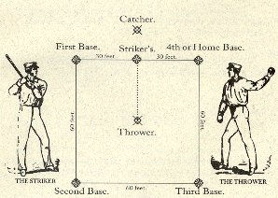

- The bases shall be wooden stakes projecting four feet from the ground. (1858 Massachusetts Rules)

- The striker shall stand inside of a space of four feet in diameter, between the first and fourth base. The catcher shall not enter within these lines, and must stand,
in all cases, while catching the ball. The thrower shall stand thirty-five feet from the striker, on a parallel line occupied by the striker. (1858 Massachusetts Rules) The striker must not throw the bat after hitting the ball. If the bat is thrown the striker will be called out and may be removed from the game at the discretion of the umpire.

- Players must take their knocks in the order in which they are numbered; and after the first inning is played, the turns will commence with the one succeeding the one lost on the previous innings. (1858 Massachusetts Rules)

- The ball being struck at three times and missed, and caught each time by a player on the opposite side, the striker shall be considered out; or if the ball be ticked or knocked, and caught on the opposite side, the striker shall be considered out; but if the ball is not caught after being struck at three times, it shall be considered a knock, and the striker obliged to run. (1858 Massachusetts Rules)

- Three hands out, all out. (Knickerbocker Rules, 1845)

- A player running the bases shall be out if the ball is in the hands of the adversary on the base, or the runner is touched with it before he makes his base. (Knickerbocker Rules, 1845)

- If a player, while running the bases, be hit with the ball thrown by one of the opposite side, before he has touched the home goal while off a base, he shall be considered out. (1858 Massachusetts Rules) In all cases the thrower should aim below the waist. If the umpire determines that the thrower did not aim for below the waist the runner will be called safe and the thrower may be removed from the game. This rule can be taken out of the game at the request of the teacher however it makes it hard for teams to record outs otherwise.

- If a ball be struck, or tipped, and caught, either flying or on the first bound it is an out. (Knickerbocker Rules, 1845)

- A player having possession of the first base when the ball is struck by the succeeding player, must vacate the base, even at the risk of being put out, and when two players get on one base, either by accident or otherwise, the player who arrived last is entitled to the base.

- The ball must be thrown - not pitched or tossed - to the bat, on the side preferred by the striker, and within the reach of his bat. (1858 Massachusetts Rules)

- Should the Striker stand at the bat without striking at good balls thrown repeatedly at him, for the apparent purpose of delaying the game, or of giving advantage to players, the Referees, after warning him, shall call one strike, and if he persists in such action, two and three strikes; when three strikes are called, he shall be subject to the same rules as if he struck at three fair balls. (1858 Massachusetts Rules)

- A player, after running the four bases, on making the home bound shall be entitled to one tally. (1858 Massachusetts Rules)

- Have fun.

