Ships of the Civil War

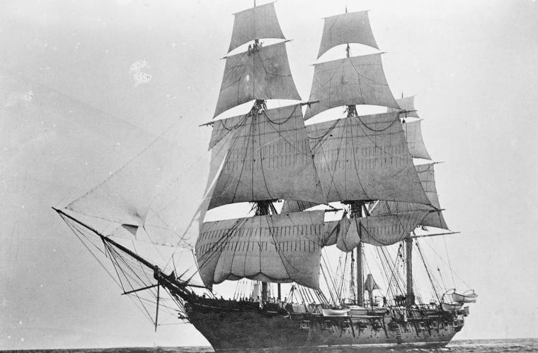
The Old Line: Sloops of War
Library of Congress
The sloop-of-war, protected by wood and driven purely by wind power, was a common sight early in the 19th century.
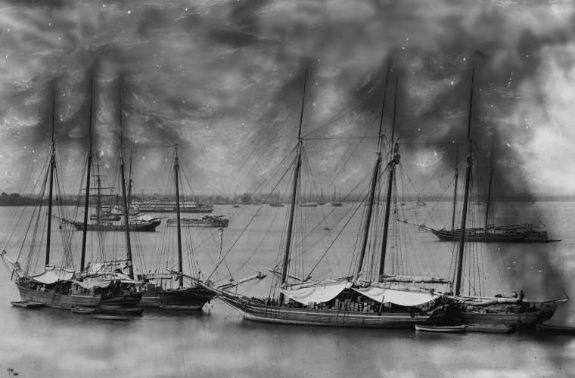
Little Helpers: Schooners
Library of Congress
Schooners were small sailing ships that were usually assigned to support duties within the fleet.
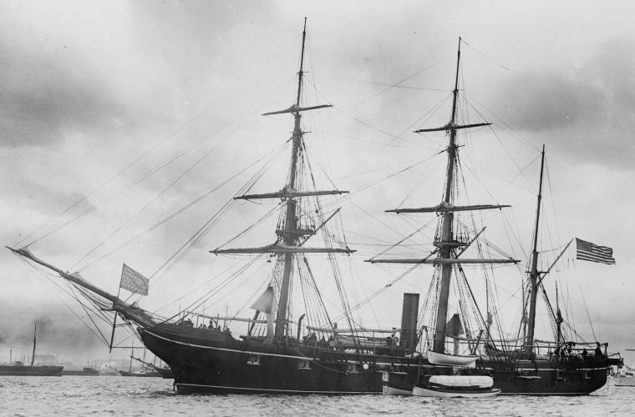
Technological Advancement: Screw Sloops
Library of Congress
Screw sloops were fast and lightly armed steamships that used propellers to move through the water.
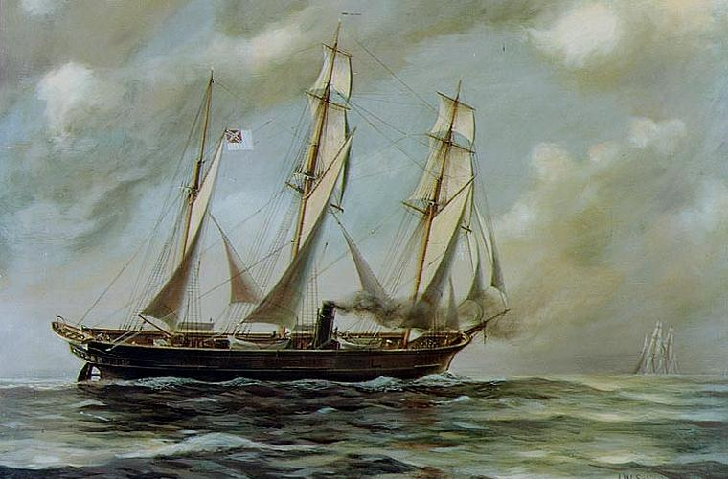
CSS Alabama
Naval Historical Center
The screw-sloop CSS Alabama was the most famous Confederate raider of the war, capturing or sinking over 60 prizes.
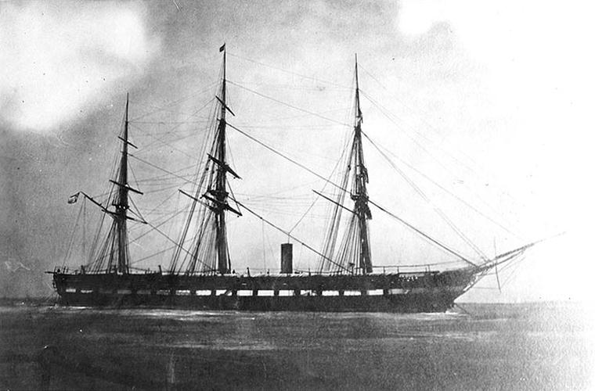
Propulsion and Power: Steam Frigates
Naval Historical Center
Steam frigates were larger and more powerful than steam sloops, although they sacrificed speed in exchange.
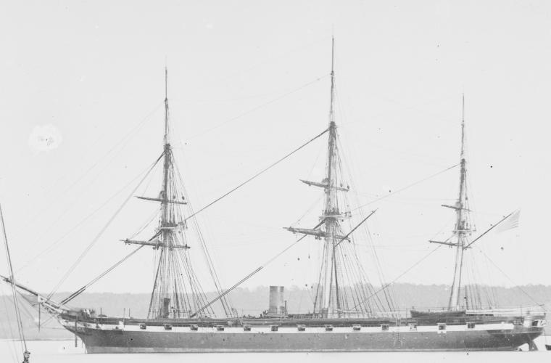
USS Kearsarge
Library of Congress
The USS Kearsarge sank CSS Alabama off the coast of France after an intense duel on June 19, 1864.
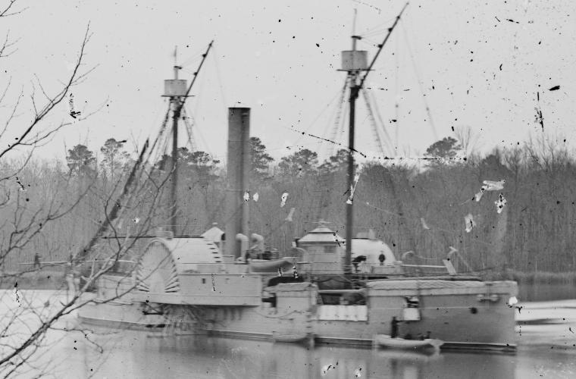
River Menace: The Double Ender
Library of Congress
Double enders were steam-powered ships with steering capability on both ends, allowing them to move backward and forward without turning around.
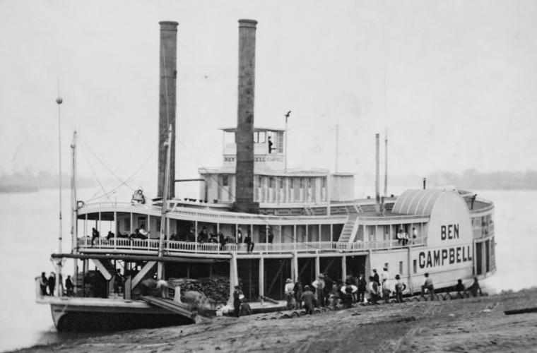
Repurposed: Paddle Steamers
Library of Congress
Hundreds of riverboats and ferries were pressed into military service as gunboats, transports, and floating hospitals.
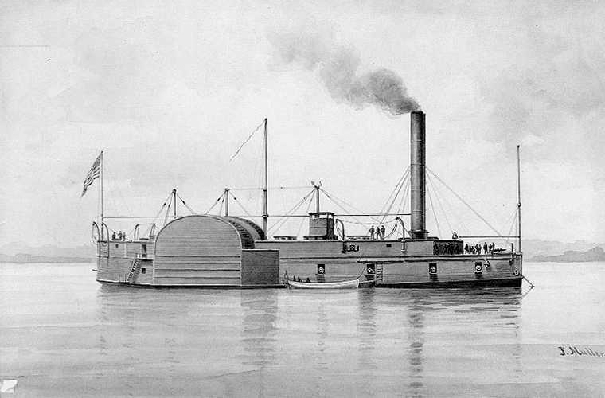
USS Lexington
Naval Historical Center
The USS Lexington was one of the war's most illustrious timberclad gunboats, one of the longest serving vessels on the western rivers. She, along with the USS Tyler and the USS Conestoga, participated in the "Timberclad Raid" of 1862, capturing or forcing the destruction of nine Confederate ships along the Tennessee River in four days.
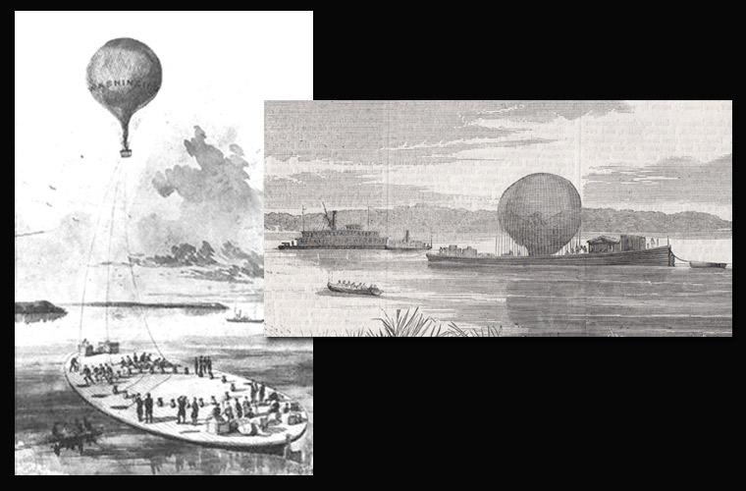
No Joke: Aircraft Carriers
Library of Congress
Specialized ships were built to transport and launch observation balloons.
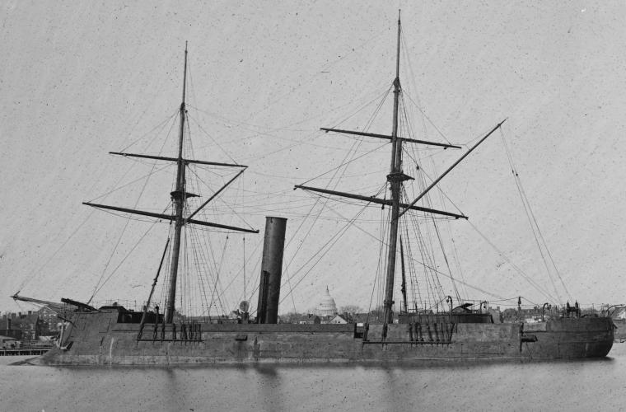
The Face of the New Navy: Ironclads
Library of Congress
The invention of ironclads set a new standard in naval combat.
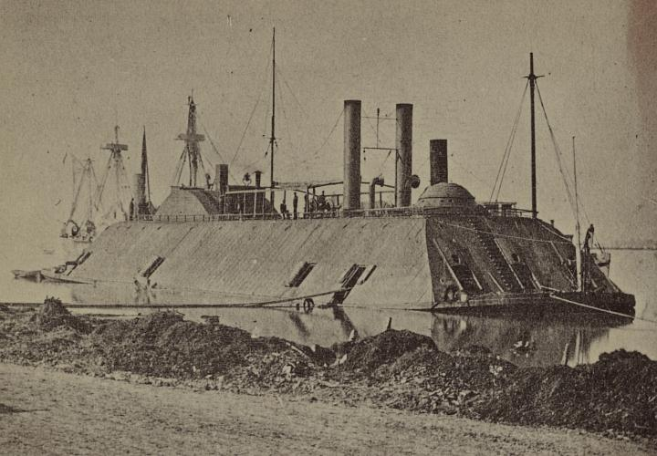
A Fortress on the Water: Casemate Ironclads
Library of Congress
"Casemate" ironclads like the USS Essex protected their gun crews with sloped armor plating.
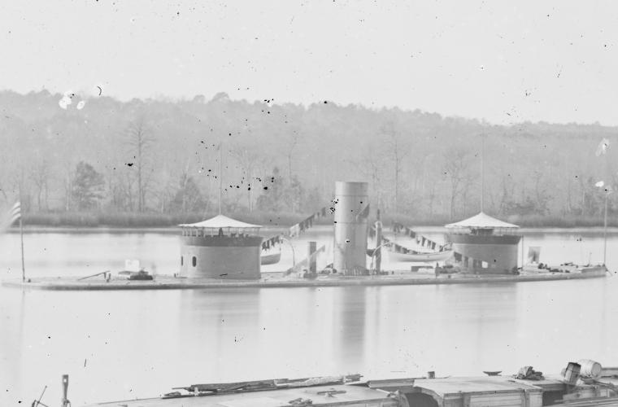
Iron Innovation: Monitors
Library of Congress
Monitor-class ironclads introduced heavy revolving turrets to the naval battlescape. The ship shown here, the USS Onandaga, sports an unusual additional turret.
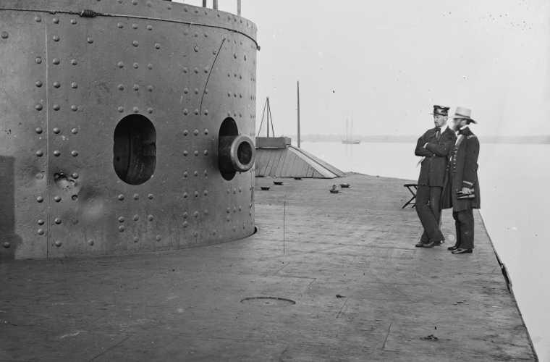
USS Monitor
Library of Congress
The USS Monitor, designed by John Ericsson, was one of the first three ironclads approved for construction by the Federal Navy. She fought the CSS Virginia to a standstill in the world's first battle between ironclad warships at Hampton Roads in 1862.
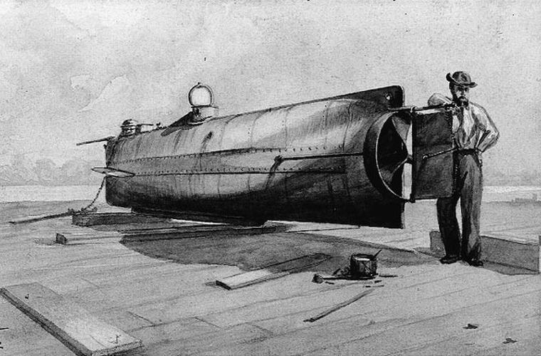
The Future: Submarines
Library of Congress
The CSS Hunley, first launched in 1863, was the first military submarine in world history to sink an enemy ship in combat. Although the Hunley's success was extremely limited--and fatal to her crew--she forever changed the nature of naval warfare.

