Volunteer/Intern Application

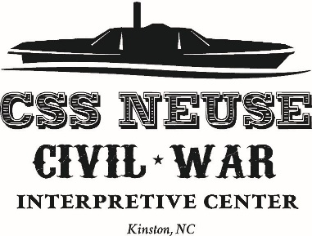
Contact Information
Name
Street Address
City, State, and Zip Code
Home Phone
Work Phone
E-Mail Address

Availability

During which hours are you available for volunteer assignments? Please fill in days and hours of availability.
Tuesday | Wednesday | Thursday | Friday | Saturday

Interests

Tell us in which areas you are interested in volunteering.
Administration
Special Events
Programs
Fundraising
School Field Trips
Guided Tours
___ Living History Demonstrations

Special Skills or Qualifications

Summarize special skills and qualifications you have acquired from employment, previous volunteer work, or through other activities, including hobbies or sports.

Previous Volunteer/Intern Experience

Summarize your previous volunteer experience.

Person to Notify in Case of Emergency
Name
Street Address
City ,State, and Zip Code
Home Phone
Work Phone
E-Mail Address

Agreement and Signature

By submitting this application, I affirm that the facts set forth in it are true and complete. I understand that if I am accepted as a volunteer, any false statements, omissions, or other misrepresentations made by me on this application may result in my immediate dismissal.
Name (printed)
Signature
Date

Our Policy

It is the policy of this organization to provide equal opportunities without regard to race, color, religion, national origin, gender, sexual preference, age, or disability.

Thank you for completing this application form and for your interest in volunteering/interning with us. If you have any questions, please contact Rachel at rachel.kennedy@dncr.nc.gov or call 252-526-9600 ext. 222.

